3D Printed Movable Tactile Pictures for Children with Visual Impairments

# ABSTRACT

## Author Keywords

Tactile Pictures; 3D Printing; Fabrication

## ACM Classification Keywords

H.5.m. Information interfaces and presentation

# INTRODUCTION

Movable pictures, such as lift-the-flap books are popular in children’s books. They are beneficial for the development of emergent literacy among young children. Figure 1.a. is an example of a movable picture from the book *What’s the opposite?,* a book that teaches preschoolers opposite spatial concepts such as up/down and lost/found. Pictures in this book are movable in a sense that the paper these pictures are printed on has non-stationary parts children can move with their hands, such as lifting, pulling, and spinning. These movements then cause the visual content of the pictures to change. For example, a child can lift a flap (comforter) and another object (toy), previously hidden underneath the flap, appears. Tangible interactions with movable pictures like this are mostly paper-based with no electronics involved. It is through such interactions children are able to connect kinetic experiences (flipping) with visual experiences (to appears) and learn novel concepts.

For those who visually impaired (VI), however, the benefits of movable pictures are limited. VI children can still obtain the kinetic experiences as they flip, pull, and spin. But they are unable to relate these kinetic experiences to corresponding visual experiences. They are unable to see that a flap is a part of a comforter, or that there is a toy underneath. Without the visual experiences made accessible to them, the kinetic experiences they got are mostly in vain with little or no educational benefit.

3D printing has been shown to be a promising method to make pictures in children’s books accessible to VI children [CITE]. A picture can be 3D modeled as a tactile picture that can be touched, felt, and understood by a blind child. Figure 1.b gives examples of 3D-printed tactile pictures made for *Goodnight Moon,* and *Harold and Purple Crayon*, two children’s book classics.

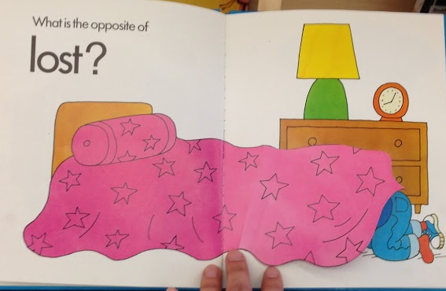 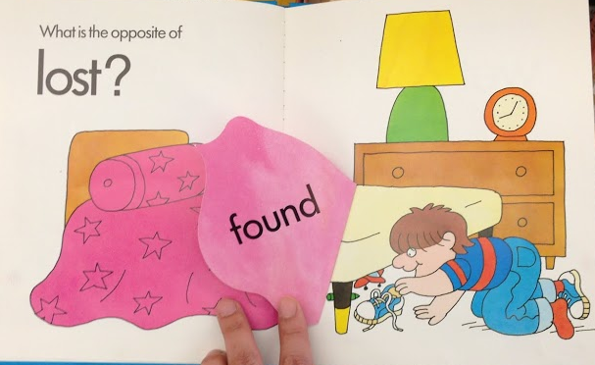

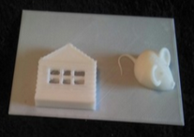 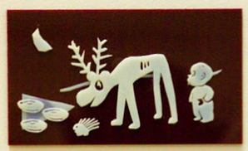

**Figure 1. Movable pictures promote emergent literacy by connecting kinetic experiences (e.g., lifting a comforter) with visual experiences (e.g., discovering a toy) (top). But this connection is broken for blind children because visual experiences are inaccessible. 3D printing makes visual experiences in children’s books accessible to blind children (bottom), but only for static pictures, not for movable pictures.**

However, 3D printing so far has been limited to the creation of static images in children’s books. Techniques previously developed for making static tactile pictures [CITE] may not apply to the making of movable tactile pictures. Movable tactile pictures pose several new challenges. In this paper, we identified three to address:

1. **Moving Primitives:** How can we create tactile models that can be flipped, spin, and pulled by children?
2. **Visual Effects:** How can we make the visual effects accessible to VI children as they flip, spin, and pull?
3. **Synthesis:**  To what extent new tactile pictures can be synthesized automatically from a given set of moving primitives and visual effects chosen by a designer?

# formative studIES

We conducted two formative studies to understand the problem space. Our main goal was to find out how a human designer, who has no expertise on 3D softwares would approach to the task of 3D modeling and printing movable tactile pictures. Informed by the findings we aimed to create an interactive system to support the design process as well as develop the underlying technical and algorithmic components to enable such system.

In our first formative study, we chose to focus on a population with high motivation but without any assumption about their 3D modeling skills. We conducted a design workshop participated by N high-school students who expressed interests in 3D printing. Students were given the task of making a 3D model based on a movable picture in a children’s book. They were also given the freedom to choose their favorite book to model. Instead of using 3D modeling software, students were given a bucket load of Lego bricks to create physical models. Figure shows some tactile movable pictures created by these students.

In our second formative study, we chose to focus on people who are knowledgeable about 3D modeling and laser cutters. The task was to illustrate a picture of a rocket covered by a cloud. The cloud is printed on a flap and can be lifted up to reveal the rocket underneath. We observed and documented the process in which the participants did this design task. Figure below shows some products of their creation. We found the design process consists of the following steps: (1) design curvy clouds, (2) abstract rocket shape in young children level, (3) model a hinge which is mathematically designed to uncover cloud so that not stuck inside during printing, and (4) combine cloud and a rocket with hinge to make the page flappable.

## DESIGN PROCESS

We present a process for creating movable tactile pictures for VI children. This process was informed by our formative studies. The input to this process is a movable picture from a non-tactile children’s book published for sighted children. The output from this process is a 3D-printable movable *tactile* picture aimed to closely approximate the kinetic and visual experiences for VI children. The major steps of this process are:

1. **Interpretation:** A human designer examines the input picture and interprets its visual content as a set of prominent objects and their relationships. For each object, she specifies a 3D tactile model suitable for representing the object. She can either search a 3D model repository (e.g., Thingiverse) or design one from scratch (if she has the skill).
2. **Movements:** She specifies which movement should be associated to each object. She can choose from a set of pre-built moving primitives to add to her design.
3. **Visual effects:** She specifies which visual effect to be triggered by the movement. She can choose from a set of pre-built effect templates. For instance, she can use an “appear effect” template and specify which tactile object to insert into the template.
4. **Synthesis:** Given a set of interpreted models, a moving primitive, and an effect template she has chosen, she can manually synthesize these individual parts into a single model using 3D modeling software. Alternatively, she can be assisted by a computer program, which calculates and suggests candidate configurations of these individual parts that meet the design parameters she specifies.
5. **Customization:** Finally, she reviews the synthesized model and customizes any property she is still not satisfied with. Examples of customizable properties include object positions, tactile thickness, and moving directions.

Supporting this design process requires us to research on (1) how to model moving primitives, (2) how to model visual effects, and (3) how to develop a program to perform automatic synthesis.

# moving primitives

Our first research challenge was to figure out how to model moving primitives. The goal was to derive a common vocabulary of moving primitives that can be applied to as many movable pictures in today’s children’s books as possible. We surveyed N children books with movable pictures and identified four most common classes of movements: hinges, pulleys, spinners, and swings. We went through a number of design iterations and arrived at a vocabulary of ready-to-print moving primitives that can be added to tactile pictures to make them movable. The figure below shows our final 3D models.

|  |  |  |  |
| --- | --- | --- | --- |
| Hinge | Pulley | Spinner | Swing |
| Macintosh HD:Users:qubick:Desktop:Screen Shot 2014-09-02 at 9.39.30 PM.png | Macintosh HD:Users:qubick:Desktop:Screen Shot 2014-09-02 at 9.39.51 PM.png | Macintosh HD:Users:qubick:Desktop:Screen Shot 2014-09-02 at 9.39.39 PM.png | Macintosh HD:Users:qubick:Desktop:Screen Shot 2014-09-02 at 9.40.00 PM.png |

# VISUAL Effects

After developing a set of tactile movable primitives, our next research challenge was to figure out how to combine tactile pictures with these primitives in order to achieve certain *tactile* visual effects. Our approach is to design a set of visual effect templates. Each template is a 3D model that has one or more placeholders for attaching tactile pictures. We found a wide range of visual effects in children’s books. We decided to focus on four common types: appearance, replacement, transformation, and movement.

## Appearance

An *appearance* effect is when an object is initially hidden from a scene and then appears in the scene after a child performed an action. Take a street scene as an example. A car may be initially hidden underneath a flap. After a child lifted the flap, the car appears. In cases like this, only one object is involved. We have developed a tactile template to achieve the appearance effect. This template has one placeholder for a single object. Above the placeholder is a cover that can hide the object. Joining the cover to the canvas is a moving primitive, such as a hinge. To use this template, a designer can choose an appropriate tactile model to represent the object. For example, there are many choices of the tactile cars on Thingiverse to represent a car. A designer may choose one with a simple design she believes most suitable for a blind child. Then, she can insert this model into the placeholder. This is all she needs to do to create a movable tactile picture with an appearance effect. It does not require advanced 3D modeling skill for mechanical components.

|  |  |
| --- | --- |
| Macintosh HD:Users:qubick:Desktop:Screen Shot 2014-09-04 at 10.39.54 PM.png | Macintosh HD:Users:qubick:Desktop:Screen Shot 2014-09-04 at 10.59.08 AM.png |

## Replacement

A *replacement* effect involves two objects. Initially, one object, X, is covered by another object, Y. After a child performed an action, Y disappears and in its place X appears. For instance, a rocket is initially covered by a cloud. After a child lifted the cloud, the rocket underneath is exposed. As a result, the cloud appears to have been replaced by the rocket. This effect can be reversed when a child performed the opposite action (e.g., put down a flap).

We have developed a template to achieve the replacement effect. This template has two placeholders, one for the object above and the other for the object beneath. It is illustrated in the figure below. This template is built upon the template for appearance effect described earlier and has a similar structure. But this template is more complex because (1) a tactile picture can be placed on top of the flap, (2) there are two layers of tactile patterns resulting in greater overall thickness, and (3) the shape of the flap can be irregular (e.g., the shape of a cloud).

Below is an example of a movable tactile picture created using this template.

|  |  |
| --- | --- |
| Screen Shot 2014-09-02 at 3 | Macintosh HD:Users:qubick:Desktop:Screen Shot 2014-09-04 at 10.35.40 PM.png |

Often, two replacement effects can be combined into one. A good example can be seen in the *Little People Lift the Flap* series. A compound replacement effect typically involves two pairs of objects {X1, X2} and {Y1, Y2} that share the same flap. As a child turns the flap from one side to the other, the child can observe X1 replacing X2 or Y1 replacing Y2. Take for an example a picture of two trees standing side by side. A flap is between the two trees. Initially, both trees appear to have nothing but leaves. By flipping the flap to the other side, the two trees now have an acorn and a squirrel respectively.

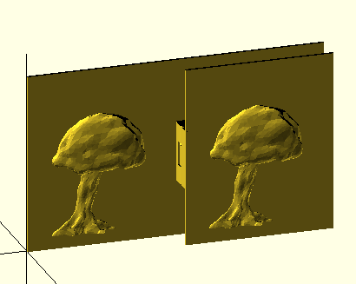 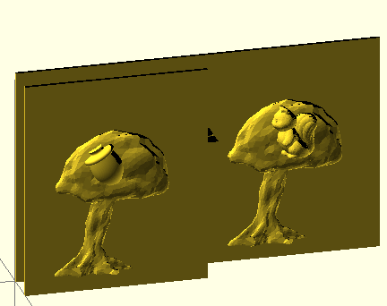

We have developed an extended version of the template to provide four placeholders. The figure below shows the above view of this template (left) and an application of this template to implement the tree example above (right).

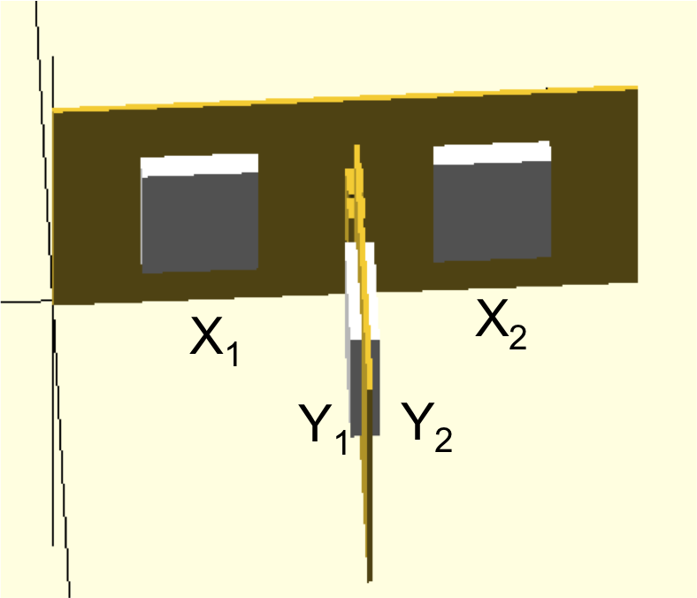 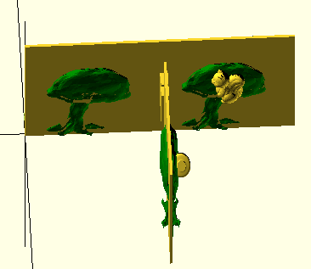

**Figure XX. Tactile pictures (right) are adapted into placeholders of the template (left), X1, X2, Y1, and Y2**

Below are two examples of compound replacement effect.

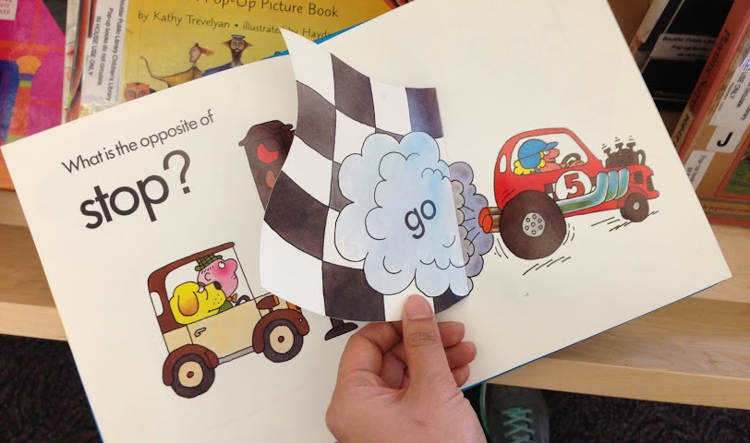 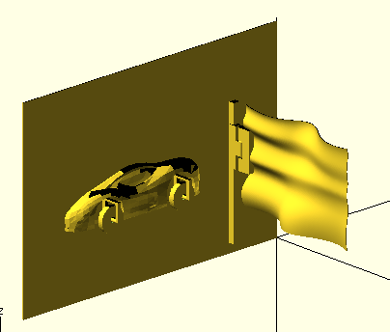

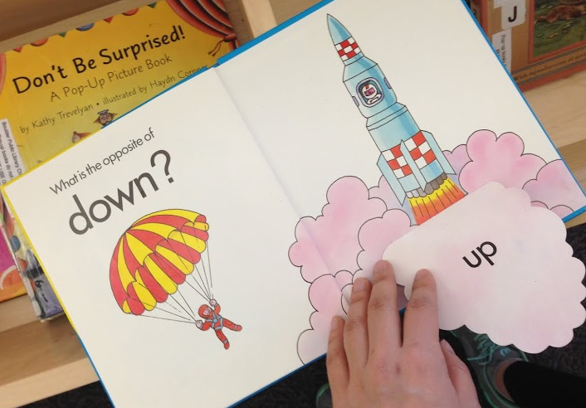 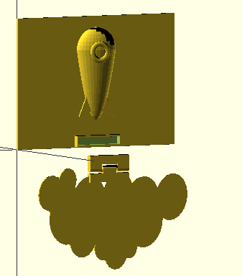

## Transformation

A *transformation* effect is when an object’s appearance is altered as a child performs some action. We observed that in most children’s books, transformation is localized to a portion of an object. For instance, a child lifts a flap and a bunny’s ears become longer.

We have developed a template to achieve transformation effects. In this case, the template has three placeholders. One is for the portion of an object that does not change (i.e., Y, bunny’s head). The other two are for the before and after pictures of the portion of the object that does change (i.e., X, large ear of bunny, and X’, small ear of bunny). The figure below illustrates this template and a specific application of this template to create the bunny example.

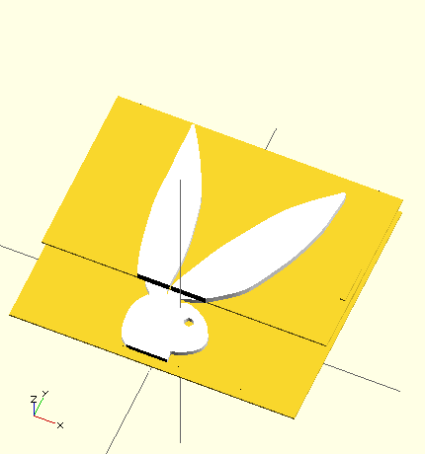 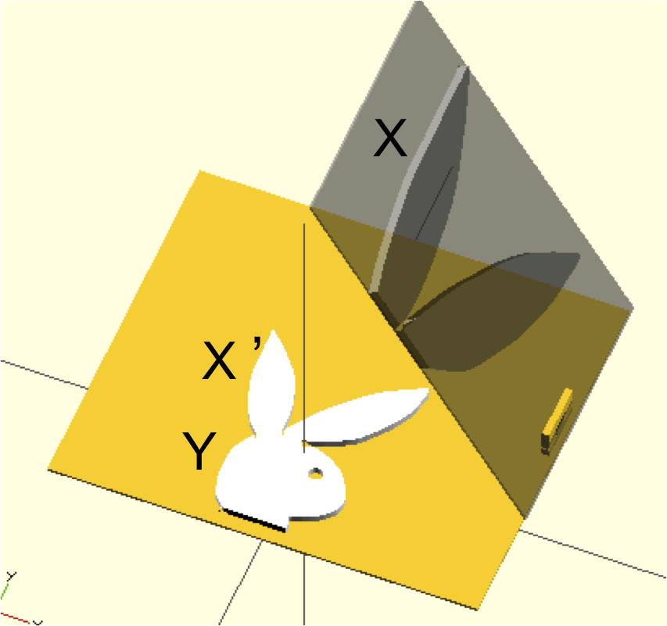

## Movement

A *movement* effect is when an object’s spatial properties are modified without any change to its appearance. For instance, a Ferris wheel’s orientation is changed as a child spins it. A rocket’s height is changed as a child pulls it up. There is often a direct mapping between a child’s hand movement and an object’s movement.

|  |  |  |
| --- | --- | --- |
| Macintosh HD:Users:qubick:Desktop:Screen Shot 2014-09-04 at 11.48.28 AM.png | | Macintosh HD:Users:qubick:Desktop:Screen Shot 2014-09-05 at 12.36.56 AM.png |
| Macintosh HD:Users:qubick:Desktop:Screen Shot 2014-09-04 at 8.59.34 PM.png | Macintosh HD:Users:qubick:Desktop:Screen Shot 2014-09-04 at 4.19.06 PM.pngMacintosh HD:Users:qubick:Desktop:Screen Shot 2014-09-04 at 4.18.57 PM.png | |

Often, only a portion of a tactile picture, such as a door of car, is movable. Below are four examples. The first two examples are based on the book *Maisy Mouse Series*. In the first example, only wheels of a car can be spun by a child. In the second example, a mouse is drinking juice from a cup, while indicating left over amount of juice. A child can pull a pulley to touch and feel the level of juice in a glass is dropping. The third example is a bathroom scene. A pulley is connected to toilet paper to represent the paper is rolling down. In the fourth example, a bird is sitting in a swing attached to a tree branch. It can be swung around by a child.

|  |  |
| --- | --- |
| frUHO6Z4El7eRG7Au5vu9HIv8LngJRGN_MZYnHHUbwvLcZnzbDn0sravqwnOMvg0ouRxLbxQ2UROgQsJCtIFGOI7rmrH2PCH2N8A34ctF9r4jpA-P3Rh7TiXtiV1K3tXuQ | Macintosh HD:Users:qubick:Desktop:Screen Shot 2014-09-05 at 12.34.05 AM.png |
| KmOEPKpHwfzB7hpsNJo4pkXbJBAwWh89QNxTHsL7cg9ddsPvk3gDW7sCgBuR5a-ht19AZ-HSXM4kTu5goXe-0OnXBaUX_GmHwWtFVxs5Cmx5m25LNFWfPxF51RnnYeSV0Q | Macintosh HD:Users:qubick:Desktop:Screen Shot 2014-09-05 at 12.38.48 AM.png |
| SMBVGCczoedh1mz5tftpMXb3d9qOn5P9puZ_2v7wIh_x1KVQflnAE0cg-DjDt64fLhcClwaixkPHGKa_NfgVW5LZSyVzMOjJmtib1iEsBP9JbZdxZJ9FQIMEocW3aoJI3w | Macintosh HD:Users:qubick:Desktop:Screen Shot 2014-09-05 at 4.52.45 PM.png |
| Screen Shot 2014-09-02 at 3 | Macintosh HD:Users:qubick:Desktop:Screen Shot 2014-09-04 at 10.58.09 PM.png |

## AUTOMATIC SYNTHESIS

After developing a vocabulary of moving primitives and a suite of visual effect templates, we set out to tackle our third research challenge, which is to figure out a method to synthesize these parts into a single movable tactile picture.

Initially, we envisioned the synthesis as a manual process. Our plan was to create all component models using popular 3D modeling software such as Maya or Sketchup. We would share these models we had created for people to download and use as building blocks to construct movable tactile pictures. For example, a Sketchup user can import into the design space a hinge model, an “appear” effect template, and a car model. She can use Sketchup’s GUI to join them into a single model, which would involve moving, scaling, and rotating the car model to fit into the template’s placeholder and inserting the hinge model at the right place. In other words, the design effort required for movable tactile pictures has been reduced to piecing together individual pre-made components; designers no longer need to “re-invent” the wheels, hinges, or pulleys.

However, we found that for our target population, this reduction in design effort is still not enough. To them, 3D software modeling tools available today still present a steep learning curve [CITE Abby’s submission]. They may have an idea how various pieces ought to fit together, the challenge children’s intellectual curiosity. But they lack the skill to operate the tool to carry out the idea. Thus, we were motivated to look into methods to automate the synthesis steps. We drew inspiration from Google Plus’s “Stories” [CITE] feature. This feature allows a user to simply upload a set of photos and a computer program automatically synthesizes them into an interactive digital storyboard. Ideally, we wanted to support an analogues experience. A user simply chooses individual parts (i.e., moving primitives, effect templates, tactile models) and a computer program can automatically synthesize them into an interactive tactile picture.

To create such a program, we resorted to OpenSCAD, a modeling tool based on writing a script to define constructive solid geometry (CSG) or extrusion of 2D outlines. An OpenSCAD script can be written to take parameters. These parameters can be used to define aspects of a 3D model that can be changed. In our application of automatic synthesis of movable tactile pictures, the parameters would include a moving primitive *m,* an effect template *T,* and a list of object models {o\_1 … o\_n} to populate the template. Then, the job of the script is to generate a model based on these parameters. This technique is often referred to as parametric 3D modeling. OpenSCAD has been used by previous works published CHI to design parametric 3D models for tangible visualization (parameters are time series) [CITE] and tactile math diagrams (parameters are trigonometric functions) [CITE].

We revisited the models we created in 3D modeling software and recreated them in OpenSCAD. Each model would be expressed as a function in OpenSCAD. For instance, the *appear effect* template is a function with the following signature:

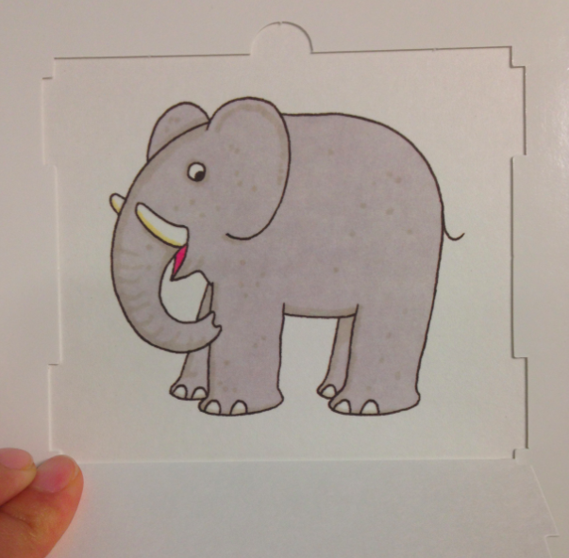 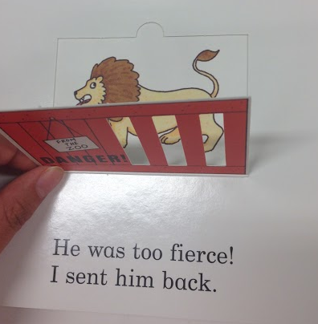 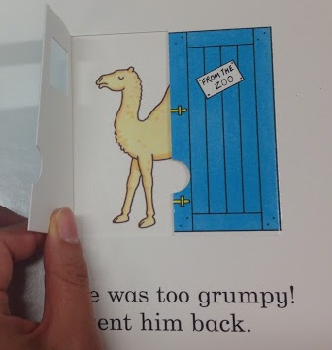 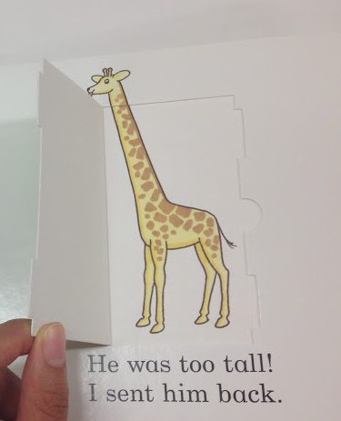 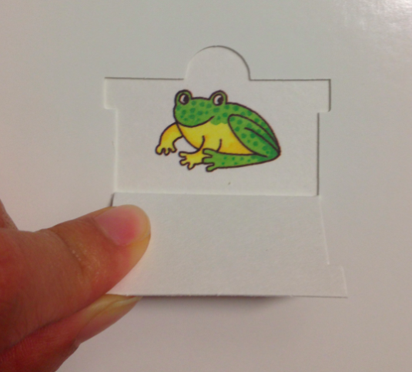 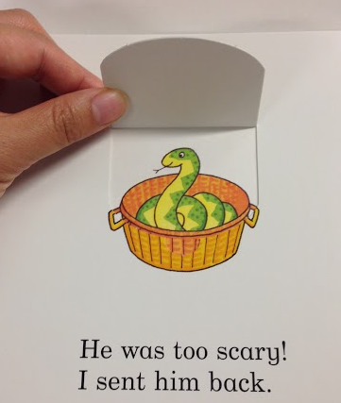 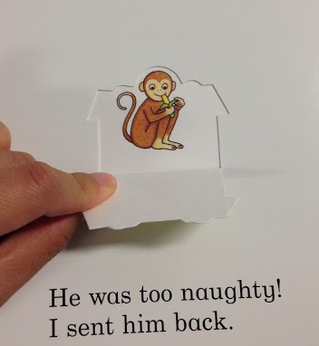 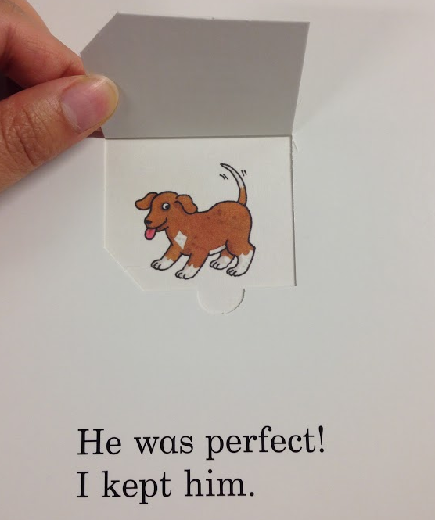

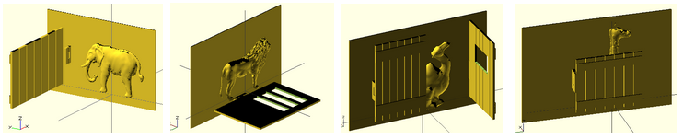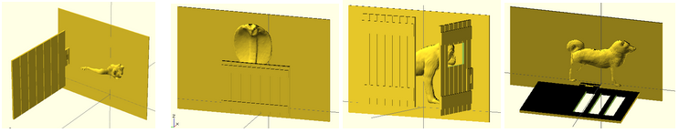

appear\_effect(mov, obj, [param1, param2…])

Recall that the appear effect is the simplest visual effect we considered, which involves only one object, denoted as *obj.* The moving primitive to trigger the effect is denoted as *mov*. Lastly, this function takes a list of optional parameters to customize certain aspects, such as the orientation of movement and the thickness of the tactile pattern.

We have developed a suite of parametric OpenSCAD scripts. To clarify, these scripts are *not* intended to be used directly by end-users. Rather, they are to provide the necessary backend functionality on top of which a GUI frontend can be built for automatic synthesis of movable tactile pictures. For instance, a user may go through a dialog window to choose an effect, a moving primitive, and a tactile model. Then, in the background, these inputs would be used to invoke the *appear\_effect* function to generate a model. This model is then displayed to the user for review. The user may find that the thickness of the model ought to be increased. She drags the thickness slider up and hits the “Regenerate” button. The *appear\_effect* function is invoked again, but with a larger value for the thickness parameter. A new model is generated and displayed to the user. She can continue to revise the model until she is satisfied. Note that the exact design of the front-end GUI is not the focus of this paper. We offer a sketch only as proof-of-concept. The main focus of this paper is on the underlying parametric 3D component models to enable automatic synthesis of movable tactile pictures.

# EVALUATION

## Dear Zoo

We evaluated our approach by transcribing all the pages of the book, *Dear Zoo*, into movable tactile pictures. This was a book chosen by our workshop participants during our formative studies. The story is about animals children can typically see in a zoo and fences in front of each animal for children to “open” the fence and “discover” the animal. This book serves as a good test bed for the model synthesis function we developed. Figure 5 shows the models generated by our OpenSCAD program for eight of the pages in the book. These pages share a common moving primitive (i.e., hinge) and effect template (i.e., appear). But they vary in the object model (e.g., elephant, horse) that populates the template. Also, each page is further customized differently in terms of the orientation of the hinge (horizontal vs. vertical), coverage (half vs. full), and configuration (one-side vs. split). The animal objects were imported from Thingiverse. This example demonstrates that the tactile components we have created can indeed be reused and applied to synthesize a wide range of movable pictures.